**Stand Up 1 (Project Planning)**

**TEAM MEMBERS:**

| **Student name** | **Student ID** |
| --- | --- |
| Phan Huy Quang | 104177128 |
| Nguyen Cuong Nhat | 104178590 |

**Time and day of regular meeting slot:**

| **Time** | **Meeting format** | **Purpose** |
| --- | --- | --- |
| Saturday night, 9pm - 11pm | Online, through discord | Sharing materials, discuss forward decisions |
| Monday noon, 12pm - 1pm | Offline, at Duy Tan | Resolve any confusions, code together difficult part |
| Thursday night, 9pm - 11pm | Online, through discord | Review code, visualizations, suggest improvements |

**Summary of to-dos before next meeting:**

* Briefly read through other project stand-ups
* Read through Data Visualization Project: Process Book on Canvas
* Ask lecturer about the project, what to do, how to achieve high marks and some advice
* Check out some visualization designs to suggest idea for the project
* Check through the dataset (if there is one)

**Github repository:**

<https://github.com/nhat120904/COS30045-Data-Visualization-Project.git>

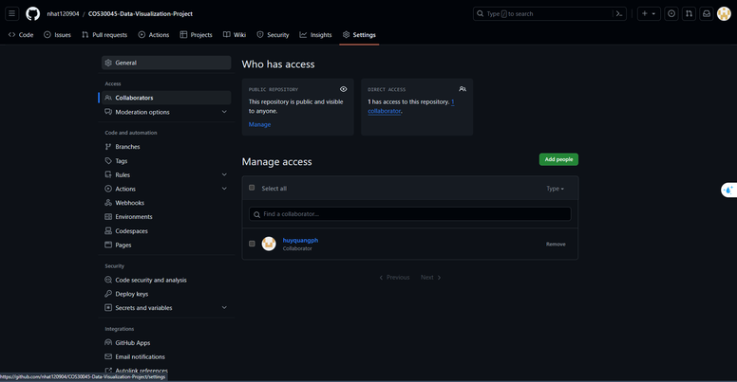

**Communication channel:**

Our group have chosen Discord as the communication channel as this application allow us to reach each other quickly, communicate using texts or voice, video calls, screen sharing with high resolution and we can also upload files through discord. This application also mitigate lagging.

On discord we will be hosting regular meetings, share materials that we found are helpful and also notify others about important things.

Communication will be mainly in Vietnamese for convenience.

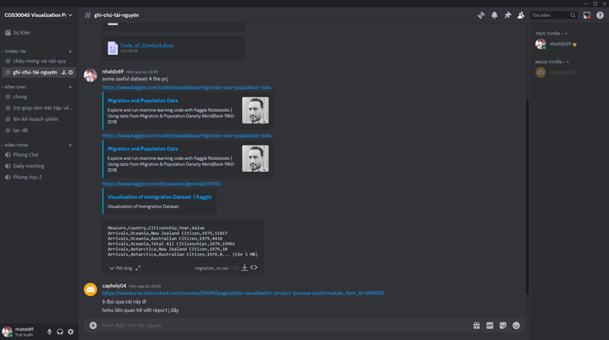

**Shared drive/ Documentation:**

[COS30045](https://drive.google.com/drive/folders/1wT0prcp2FrxyhkAdSayQr6HWGWUtH91J?usp=sharing)

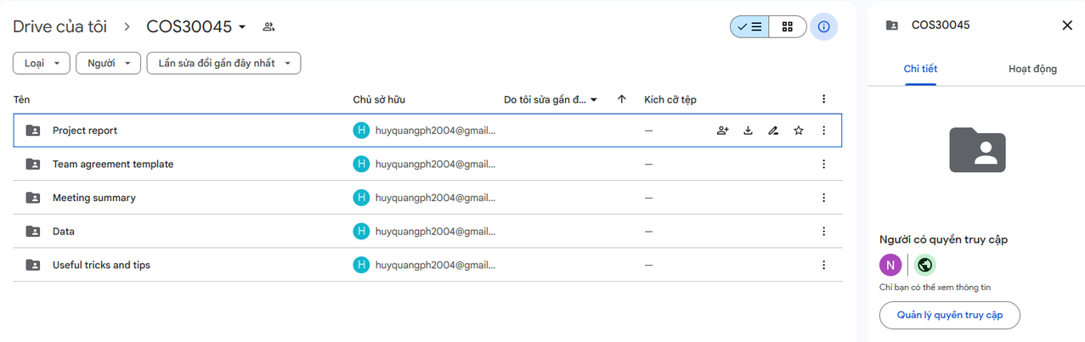

**Project schedule:**

|  | **Task** | **Notes** |
| --- | --- | --- |
| 27/1 | Project stand-up 1 | Set up communications, GitHub, shared documents |
| 30/1 | Find a dataset | Find a clean dataset that is related to the assigned topic. Should be large enough to create complex visualizations. Examine the dataset carefully to make sure it is good enough |
| 31/1 | Finalize the visualization format | Discuss to come to an agreement on what type of visualization to use so that it is easy to see, to interact and to achieve meaning of data from it. |
| 1/2 to 10/2 | Start coding | Use html, css, d3 to create a web visualization. Deadline is 20/2 |
| 11/2 to 20/2 | Documentation | Start making the documents related to the visualization. A draft should be ready by 20/2 |
| 21/2 | Improvements | Improve the code |
| 1/3 | Report writing | Making the report of the project. Should have a draft by 15/3 |
| 20/3 | Finalize | Finalize the code, data, reports. Must be done before 29/3 |
| 1/4 | Submit | Submit to canvas and present to lecturer |

**Any issues with teamwork:**

* Communication Breakdowns:
  + Issue: Ineffective communication can lead to misunderstandings, delays, and project failures.
  + Guidelines: Regularly update team members on your progress and any challenges you may be facing. Use clear and concise language, and actively listen to others during discussions. Foster an open-door policy, encouraging team members to communicate freely and seek clarification when needed.
* Lack of Accountability:
  + Issue: When team members don't take responsibility for their tasks, it can hinder overall progress and create frustration within the team.
  + Guidelines: Clearly define roles and responsibilities for each team member. Own up to mistakes and learn from them. Encourage a culture where mistakes are viewed as opportunities for growth. Hold each other accountable for deadlines and commitments.
* Limited Collaboration:
  + Issue: Teams may struggle when collaboration is minimal, hindering creativity and the exchange of ideas.
  + Guidelines: Actively seek input and feedback from team members during project planning and decision-making. Utilize collaboration tools and platforms to facilitate communication and information sharing. Foster a culture of mutual respect where everyone's input is valued.